MEDIA RELEASE
5 December 2016
LOW DENSITY RESIDENTIAL ZONES TO DISAPPER
In tandem with the release of the District Plans by the Greater Sydney Commission is the introduction of one of its greatest tools to increase density across Sydney – the proposed Medium Density Code. To date, high-rise development has been kept to areas zoned for high density. Similarly medium density can only be built in specifically designated areas to allow a graduated change from apartments to single houses.
Now NSW Government’s proposed legislation, called the draft Medium Density Housing Code, aims to extend medium density development throughout current low density single dwelling, residential areas (R2 zone) as complying development. This is in addition to the existing R3 zone which is specifically designed to deliver medium density housing.
“As complying development, developers will not need to get development application approval, with neighbours only required to be informed of these developments without the right to object. As long as the developments meet a predetermined set of guidelines they will be fast-tracked through Council. This will bring massive change to our suburbs“ said Kathy Cowley, President of Friends of Ku-ring-gai Environment Inc.
The medium density complying developments include townhouses, terraces, manor homes (2 up, 2 down) and dual occupancies. This includes up to 5 townhouses on a single lot with a minimum lot size of 1000 sqm.
What’s the problem with this proposal? Essentially three aspects.
Firstly, complying development should never be for a dwelling type that is not typical in a zone or area, or one which will change the character of a streetscape so dramatically.
Secondly, it is simply bad strategic planning. It does not take into account the cumulative effects of intensifying development on local infrastructure, services, traffic, street car parking, social services and amenities. It will create ad hoc development, permitting poor quality residential development that is not integrated with planned infrastructure.
Thirdly, there is no limit to how many of these types of complying developments will be allowed across R2 residential areas.
The draft Medium Density Code (also labelled ‘small lots discussion paper’) would lead to an effective blanket rezoning to medium density of virtually all single dwelling, low density residential land, with minor exceptions (such as Heritage Conservation Areas or Environmentally Sensitive areas), with a street frontage of 12 metres and a minimum lot size of 400 sqm.
“This is just a short-term grab for increased housing density that will support developers rather than the community that already calls an area ‘home’. The traditional amenity of a single house on a single site will be lost.” said Kathy Cowley
Complying medium density should only be considered for sites within 'core' R3 medium density zones, that is, sites where the R3 zone does not interface a lower density zone” said Kathy Cowley.
Act Now: Residents have until the 12 December to object.
Go to http://planspolicies.planning.nsw.gov.au/, link to Draft Medium Density Design Guide, and make your submission.
For media comment, please call Kathy Cowley on 0431 158 880 or 9416 9007
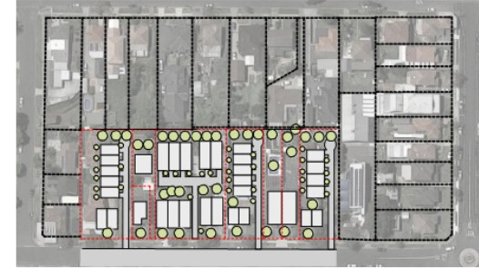
Diagram NSW Planning’s Draft Medium Density Design Guide

